**Basics about Automation**

**Story file:**

This is a “.story” file which contains one or more scenarios and each scenario is written using “Given When Then” format. This “Given When Then” statements are mapped to Java step files methods.

In this file data can be given by two ways “.table” file in key value pair or directly inside “.story” file at the end of each scenario using keyword “Examples”.

Data provided by .table file(in key value pair):

Data provided in .story file:

**Java Steps file:**

This includes Java methods with annotations such as @Given / @When / @Then to run the test scenarios.

We have many Steps file to implement various steps in .story file.

CommonSteps file to use some common functionality in .story file:

JobRunnerSteps file to use job in .story file:

**Java Story file:**

This file is also a java file which is a runner file for the “.story” file with the same name.

This file includes all the steps being used in .story file and add the steps using addSteps().

**Test suite txt file:**

This is a text file which contains “.txt” files location and this file can be used to reach out the “.java” files while running packs in Jenkins. Address of this “.txt” file is also provided as a suite in Jenkins while running packs.

**XML Request and Response:**

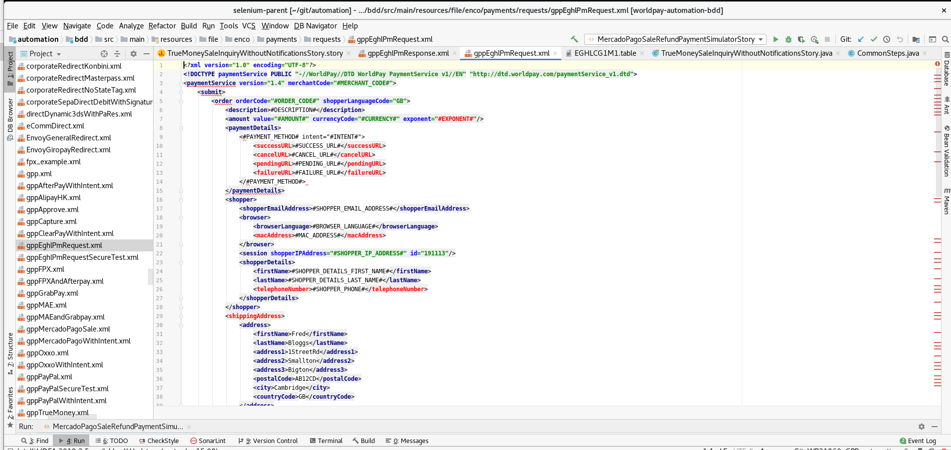

**Jenkins and packs:**

**seed-wpg-regression-automation** - this job creates all the jobs, views and folders, mostly related to the regression packs. Basically it will create all the jobs for all the packs on all the FTEs.

(Generally all pack such as Core pack(wpg_core_pack), healthcheck, PACT pack(pact_gw2_wpg),Smoke are already made)

Below are the Packs that we generally use:

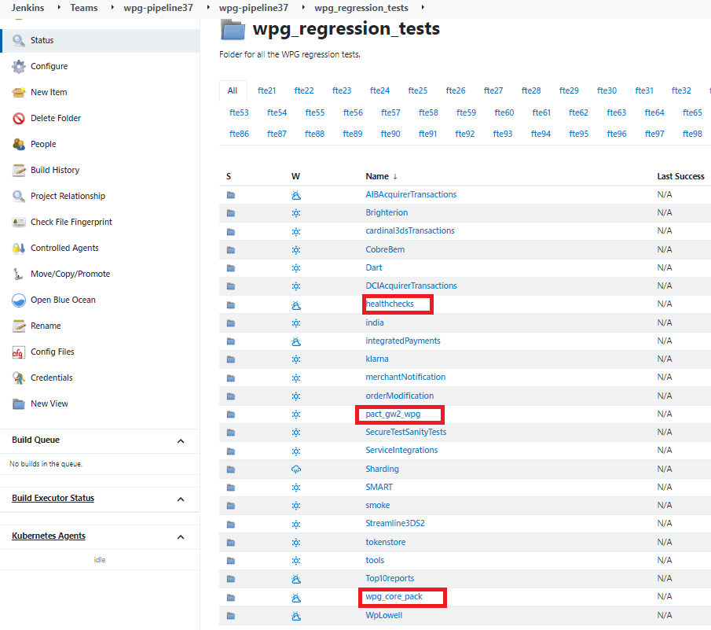

Similarly for other two packs.

**seed-wpg-project-pack-automation** - this job allows us to create specific project packs having all the necessary settings. Based on some input parameters, like branch, project name, FTE, you will be able to easily create your project pack jobs.

Note: First we build job for project pack from **seed-wpg-project-pack-automation** which is reflected in **wpg_project_tests**

Click on “Build with Parameters”

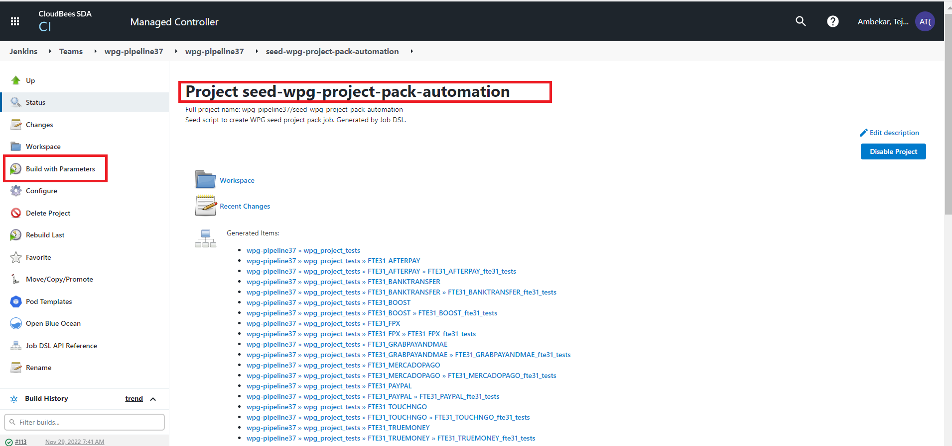

Fields to be changed:

* Project Name
* FTE number
* Location of Suite text file (from src)
* Branch Name

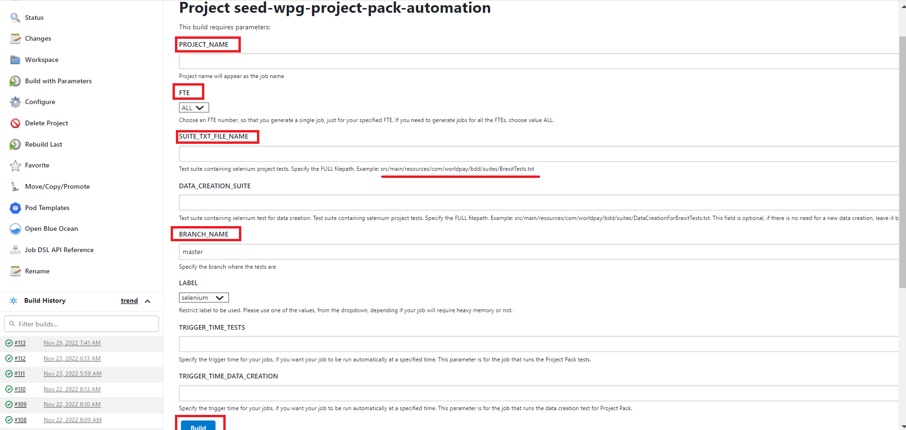

For Example I have made WP21860_TRUEMONEY_TRIAL

Click on “Build with parameters”

All Information will be available here click on “Build”

**Reports:**

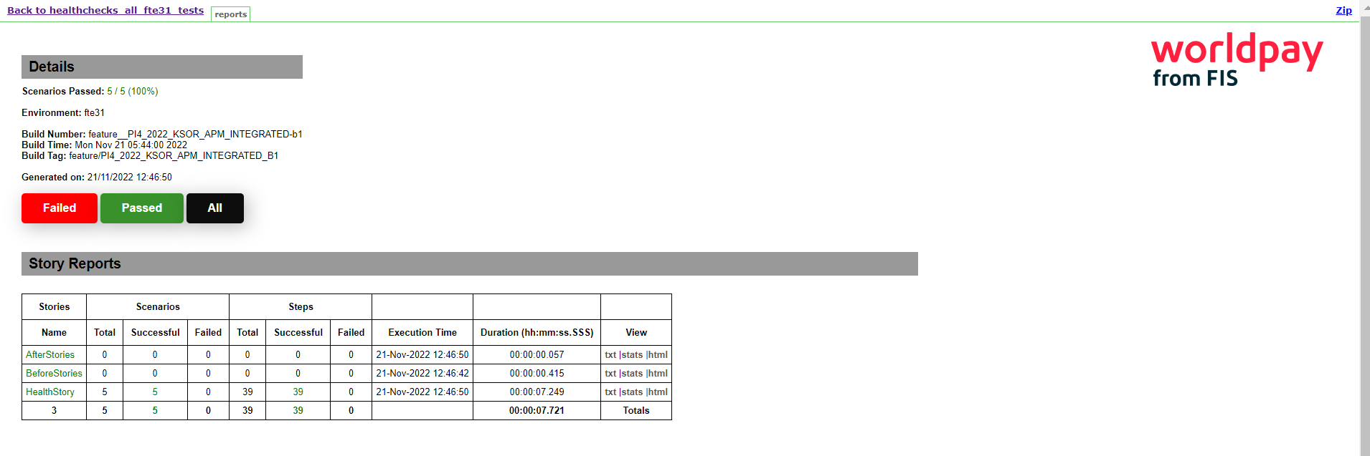

**Packs before RC :** PromptPay, Healthcheck, Core Pack, AfterPay, PayPal, MercadoPago, FPX ,GrabPay, Truemoney, BankTansfer, Boost, TouchNGo, LinePay, PACT pack

**Packs after RC (on RC branch fte81) :** Smoke(FPX, GRABPAY, MAE, BANKTRANSFER,TRUEMONEY,TOUCHNGO, BOOST, PROMPTPAY , LINEPAY,PAYPAL,MERCADOPAGO)